Group3
SERENA WU
Questions
4.18, 4.33, 4.56, 4.76, 5.20, 5.34, 5.54, 5.72

Solution
Since,
M= 5
N=4
The answer is 5*4 = 20 ways

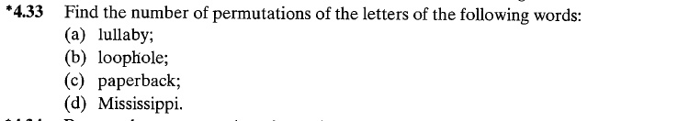
Solution
- lullaby
This word has 3 “l” and 1 copy of 4 more letters.
Hence 7P3
$$\frac{7!}{\left(7-4\right)!}$$
$$=840$$

- loophole
This word has 3 “o” and 2 “l” and 1 copy of each of 3 unique letters.
Hence
$$\frac{8!}{3!2!}=3360$$

- paperback
Similarly, arrangements are:
2 “p , 2 “a” and 5 unique letters
- $\frac{9!}{2!2!}$
$$=90720$$

- Mississippi
We have 4”s”, 4”I”,2”p” and 1 m
Hence the permutations are:
$$\frac{11!}{4!4!2!}$$
$$=34650$$

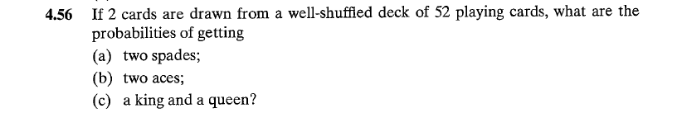

Solution
Total no of ways of drawing 2 cards from a well-shuffled deck of 52 playing cards = ⁵²C₂ = 1326
a)
Probability of getting two spades = no of ways getting 2 spades/total no of ways
= (¹³C₂)/1326 = 78/1326
= 0.0588
b)
Probability of getting two aces = no of ways getting 2 aces/total no of ways
= (⁴C₂)/1326 = 4/1326
= 0.003
c)
Probability of getting a king and a queen
= 13*13/1326
= 0.12745

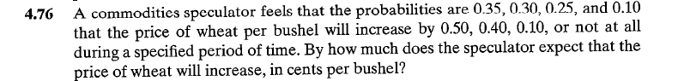
Solution
The expected value of increase is given by:
Thus the speculator expects that the price of wheat will increase by 0.32

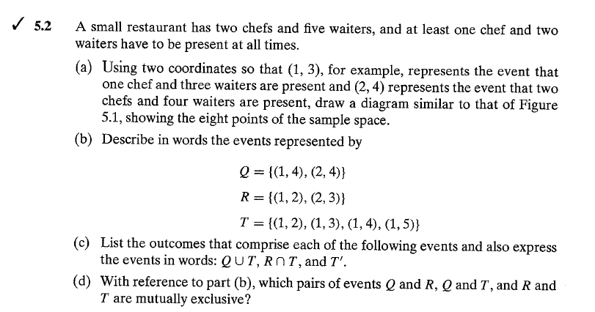

Solution

- Q is the event that only 4 waiters will be present with either one or the two chefs.
R is the event that at least one chef will be present with either two or three. waiters.
T is the event that at least two waiters will have a chef.

- QꓴT={(1,2),(1,3),(1,4),(1,5),(2,4)}
At least one chef will be present when at least 2 of the 5 waiters are present
RꓵT = {(1, 2)}
Only one chef is present with only 2 waiters
T’= {(2, 2), (2, 3), (2, 4), (2, 5)}
Only two chefs are present when at least two waiters are present

- Q and R are mutually exclusive since QꓵR = {Ꝋ}

Solution
Let p be the probability of passing the course, then she must have a bet if expected money on bet is on gains not on loss.
i.e. as expected gain >0
thus
25p+(-5)(1-p)>0
25p5+5p>0
30p>5
- P> 1/6
Therefore it tells about the probability of passing must be greater than 1/6.

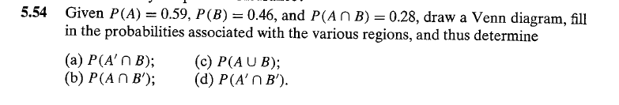
Solution
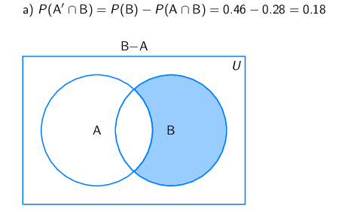

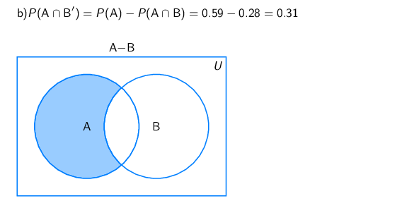

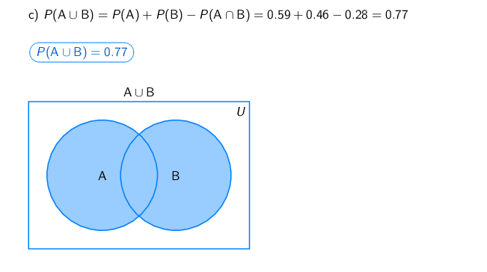
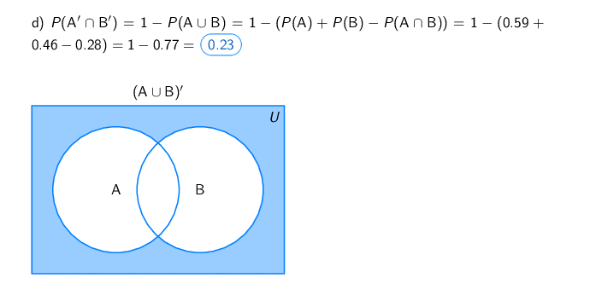

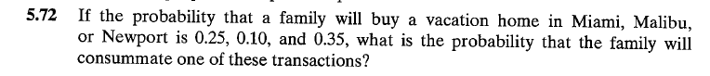
Solution
P(consummating one of these transaction) = 1- P(not consummating any of these transactions)
= 1 - (1-0.25) * (1-0.1) * (1-0.35)
= 1 - 0.75*0.9*0.65
= 0.5613

